Physical Education Lesson for the Week
May 1st- 31st – National Sport and Fitness Month
May 4th – 8th, 2020
National Screen Free Week - During the first week of May, thousands of families, schools, and communities around the world will put down their entertainment screens for seven days of fun, connection, and discovery. You can celebrate Screen-Free Week at home, in your school, in your community, or anywhere – just put down those entertainment screens and do literally anything else! “Entertainment screens” means that you can’t use Screen-Free Week as an excuse not to do your homework or your job. But if you’re a teacher or boss, you can help everyone celebrate by reducing the amount of screen-based work you assign!
- Check out the video messages throughout the week!

- We have covered all the Muscles of the Month for the school year. We are going to continue to do a muscle of the week each week. Review the muscle with your child by saying what the muscle is for the week. Have them show you where it is on their body. Next, show them the picture on the slides to see if they were correct. Finally, explain what it is used for or have them explain what it is used for (attached you can use the slides/pictures to assist with your child).

- Continue Each Day During May to perform the activities on that specific day using your May activity calendar attached.

Monday – Perform 15 lunges each leg (use the video for a reference)
Click video link https://youtu.be/FnUEsp-mQpU

Tuesday – Perform 15 kicks with your favorite leg (practice kicking a ball, if you do not have a ball pretend a ball was there and kick it)
Critical elements to kicking:
- Running or jogging approach to the ball
- Plant your non-dominant (non-kicking) foot beside the ball
- Contact the ball with your toes or shoelaces
- Follow through on your kick

Wednesday- Perform for 30 seconds jogging in place trying to get your knees as high as you can. Attempt this exercise 3 times total. Take breaks where needed!
Click video link https://youtu.be/D0GwAezTvtg

Thursday – Perform 15 step-ups (15 up and 15 down on a single step)-use the video link as an example.
Click video link https://youtu.be/dG75KOf4EtY

Friday – Self – Test day- follow the example video provided to help you perform the fitness test for the week involving the quadriceps. This will be a great way to test your muscular strength, muscular endurance, and quadriceps for the week once you have completed all the daily skill/fitness routines.

Self – Test Video = Click the Icon https://youtu.be/6etwjsnMORQ

Try the Following for Friday’s Self-Test Day: Shuttle Run -Refer to the description at the bottom of the lesson.
Perform Quadricep Self-Test = Fitness Level or Titan Level (refer to charts provided below)

Be Safe, Be Healthy, Stay Active!
Shaler Area School District
Primary PE Department
Yours in Fitness and Health,
Mr. Chmielewski
Muscle of the Week
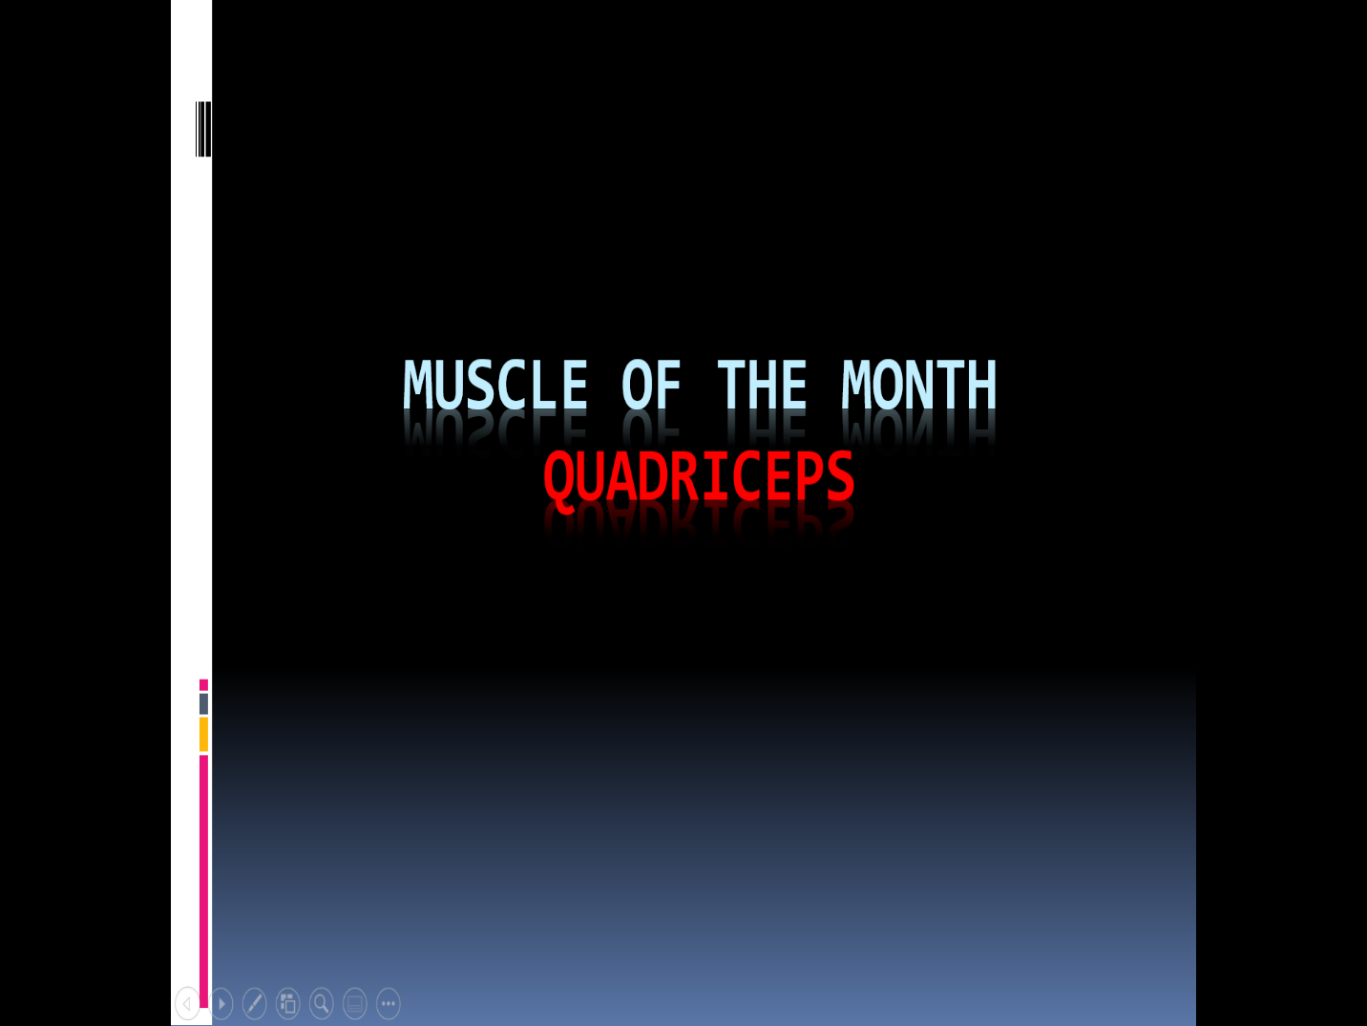

Muscle of the Week

Function of the Quadriceps
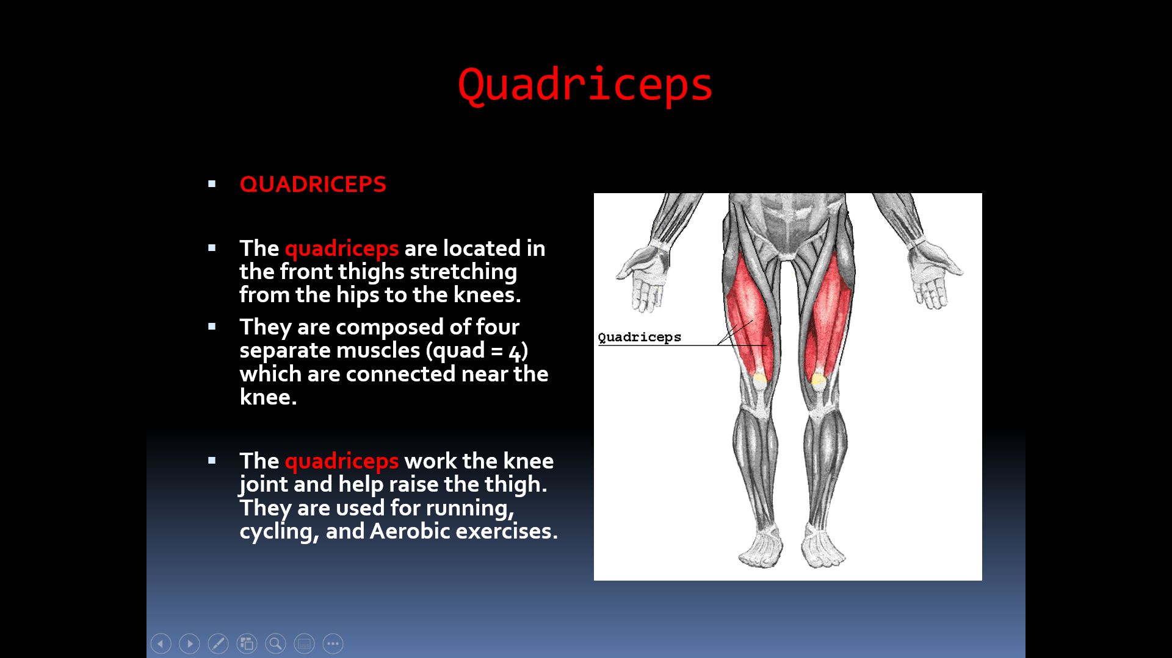

How do we use these muscles in PE?
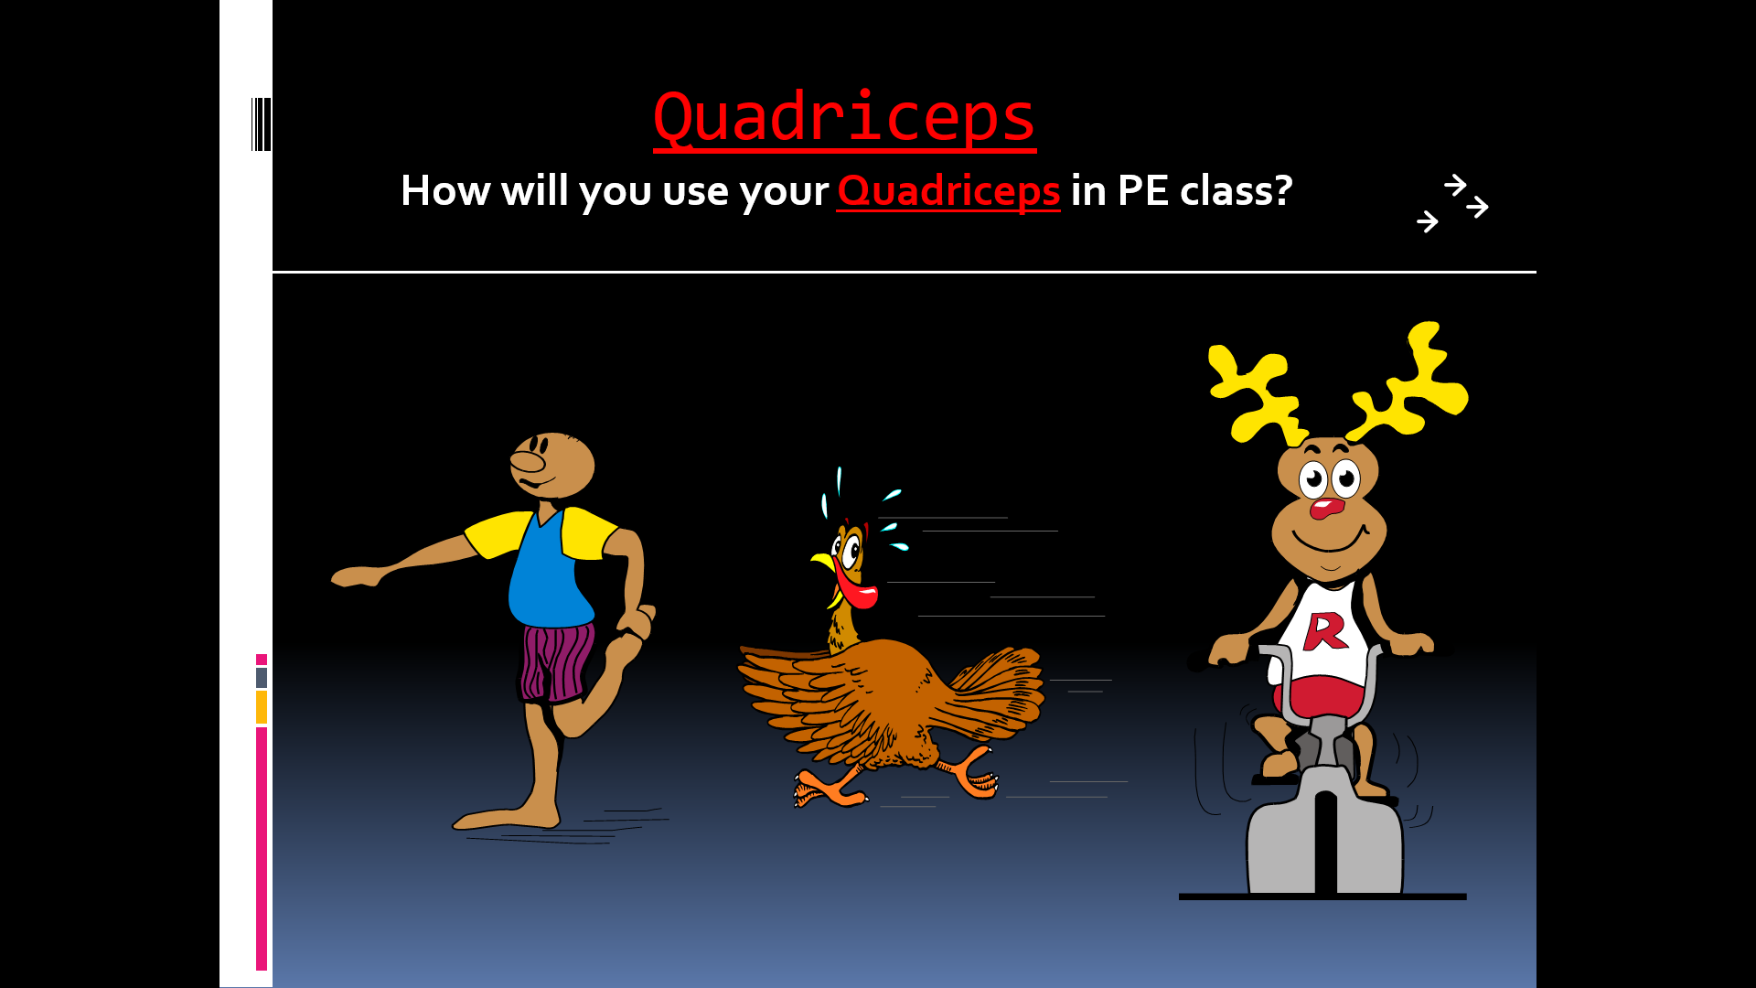
Fitness Test-we use the Quadriceps in PE CLASS to test muscular strength and muscular endurance – Shuttle Run Test

National Observances  ● May 1-7: National Physical Education and Sport Week ● May 4th: Star Wars Day  ● May 5th: Cinco de Mayo  ● May 6th: National Nurses Day ● May 10th: Mother’s Day |  |  |  |  | 1 Commercial Break  Can you hold a plank for an entire TV commercial break? | 2 Dribble Challenge  Dribble a ball 100 times with each hand. Can you successfully dribble 100 times with each hand while moving?
3 How Fast Can You Go?  Pick a distance and see how fast you can run the distance. | 4 Star Jumps  Jump up with your arms and legs spread out like a star. Do 10 then rest and repeat. | 5 Celebrate  Put your favorite song on and make up a dance or fitness routine! | 6 A Gratitude Attitude Write down something you’re thankful for and why. | 7 Inchworms  Keeping your legs straight place your hands on the ground, walk them into push-up position, and walk your legs up. | 8 Teacup Tip-ups  Place your hands on the ground and gently touch your forehead to the ground balancing your elbows on your knees. | 9 Musical Frogs  This game is just like musical chairs except players hop around like frogs and sit on lily pads (pillows).
10 Positive Talk  Be sure to talk to yourself today like you would talk to someone you love. | 11 Yoga  Yoga is a great way to relieve stress. Try Savasana, considered to be the hardest yoga pose! Fully relax & clear your mind. | 12 Wild Arms  As fast as you can complete: 10 Arm Circles front & back 10 Forward punches  10 Raise the Roof’s Repeat 3x | 13 Mindful Senses  What do you notice around you? Find:  5 things you see 4 things you feel 3 things you hear 2 things smell  1 thing you taste | 14 Crawl Like a Seal  Lie on your stomach, arms straight out front. Use your arms to pull your lower body along keeping your legs and back straight. | 15 Rock Paper Scissors Tag Meet in the middle, shoot, loser chases the winner back to safe zone. If tagged, join the other team.  . | 16 Family Mindful Snacking When eating a snack today, really pay attention to the taste, feel, sound, smell and look of the snack you’re eating. What do you notice?
17 Rock Paper Scissors Tag Meet in the middle, shoot, loser chases the winner back to safe zone. If tagged, join the other team. | 18 Chair Pose  Hold for 30 seconds, relax then repeat. | 19 Paper Plate Planks  In plank position with paper plates under your feet. Complete 30s each:  -mountain climbers -in and out feet  -knees to chest | 20 Commercial Break  Can you hold a plank for an entire TV commercial break? | 21 Jump, Jump  Jump side-to-side over an object or line for 1 minute straight. Go again but jump front to back. Repeat each jump twice. | 22 Positive Talk  Be sure to talk to yourself today like you would talk to someone you love. | 23 Play Catch  Grab any kind of ball and play catch with a family member. Keep your eyes on the ball and catch it with your hands not your body.
24 Before Bed Breathing  While lying in bed, place your hands on your stomach and pay attention to the up and down of your belly as you breathe. | 25 Crane Pose  Here’s a challenge! Put your hands on the ground, lean forward & balance your knees on your elbows. | 26 Step Jumps  Find a step or a bench and jump up and down 50 times. Be careful. Take a break if you need to. | 27 A Gratitude Attitude Write down something you’re thankful for and why. | 28 Wake and Shake  As soon as you get out of bed shake your body any way you like for 10 seconds. Are you up now? Good! Now jump up and down 10 times. | 29 Walls  Face each wall in a room and do a different exercise for 30 seconds  -side shuffle  -grapevine to left then right -wide stance punches  -vertical jumps | 30 How Fast Can You Go? Pick a distance and see how fast you can run the distance.
31 Wild Arms  As fast as you can complete: 10 Arm Circles front & back 10 Forward punches  10 Raise the Roof’s Repeat 3x | SHAPE America recommends school-age children accumulate at least 60 minutes and up to several hours of physical activity per day. Each bout of physical activity should be followed by cool-down stretches that help reduce soreness and avoid injury. Happy exercising!  Reproduced with permission from the Society of Health and Physical Educators (SHAPE America) https://www.shapeamerica.org/publications/resources/teachingtools/teachertoolbox/activity-calendars.aspx

SHUTTLE RUN

(seconds)
AGE | BOYS  ~  FITNESS | BOYS  ~  TITAN | GIRLS  ~  FITNESS | GIRLS  ~  TITAN
6 | 13.3 | 12.1 | 13.8 | 12.4
7 | 12.8 | 11.5 | 13.2 | 12.1
8 | 12.2 | 11.1 | 12.9 | 11.8
9 | 11.9 | 10.9 | 12.5 | 11.1
10 | 11.5 | 10.3 | 12.1 | 10.8

SHUTTLE RUN DESCRIPTION : Start with two lines 30 feet apart. (Chalk can be used for this) Place two blocks of wood behind one line or any object the students can pick up easily. Go to the opposite line and at the signal “Ready, Go” run to the other line, pick up one block(or object picked), run back to the line you started at and place it on the floor behind the line. Run back to the other line, pick up the second block (or object) and run back and cross the starting line. Do this as fast as you can, without throwing the blocks (or objects).
Have someone time you and compare your results with the charts.

